**ASSIGNMENT: WORLD DB**

**PREPARED BY: HARRISON KANAYO UWAFILI**

**COURSE: DATA TECHNICIAN BOOTCAMP**

**INSTRUCTOR: YUSUF**



**CONTENTS**

Task 1: List the different types of relationships in relational databases and provide examples.......3

Task 2: What is Normalization and why is it important to database development?............4

Import and Execute Script....................................................................................................5

Once executed you will see the below actioned Output......................................................5

New Query Tab......................................................................................................................6

Saving Task and Queries........................................................................................................6

Using count, get the number of cities in the USA.................................................................7

Find out what the population and life expectancy for people in Argentina (ARG) is............7

Using ORDER BY, LIMIT, what country has the highest life expectancy?...............................8

Select 25 cities around the world that start with the letter 'F' in a single SQL query…........8

Task 13: Creating an EER Diagram...................................................................................9-12

Identify the primary key in country table...........................................................................13

Identify the primary key in city table…………………………………………………………………….……….13

Identify the primary key in Country language table...........................................................13

Identify the foreign key in city table...................................................................................13

Identify the foreign key in Country language table………………………………………………………….13

**TASK 1: LIST THE DIFFERENT TYPES OF RELATIONSHIPS IN RELATIONAL DATABASES AND PROVIDE EXAMPLES.**

1. **ONE-TO-ONE RELATIONSHIP:** A single record in one table is related to a single record in another table.

Example:

* + Tables: Country and Country Details
  + Relationship

**2. ONE-TO-MANY RELATIONSHIP:** A single record in one table can be related to one or more records in another table.

Example:

* + Tables: Country and City
  + Relationship

**3. MANY-TO-MANY RELATIONSHIP:** Multiple records in one table are related to multiple records in another.

Example:

* + Tables: Country and Language
  + Relationship

**TASK 2: WHAT IS NORMALIZATION AND WHY IS IT IMPORTANT TO DATABASE DEVELOPMENT?**

**Normalization** is organising data in a database to reduce redundancy and improve data integrity. It involves decomposing large tables into smaller ones and defining relationships between them to eliminate duplicate data and ensure logical data storage.

**WHY IS NORMALIZATION IMPORTANT IN DATABASE DEVELOPMENT?**

**REDUCES DATA REDUNDANCY:** This avoids unnecessary data duplication, which can save storage space and simplify updates.

**IMPROVES DATA CONSISTENCY:** Since data is stored logically, changes made in one place are automatically reflected wherever that data appears.

**ENHANCES FLEXIBILITY:** Normalized databases allow easier schema modifications and expansions.

**INCREASES DATA INTEGRITY:** Ensures that the data entered into the database remains accurate and consistent.

**IMPROVES SCALABILITY:** As databases grow, normalized structures make it easier to manage large volumes of data.

**IMPORT AND EXECUTE SCRIPT** 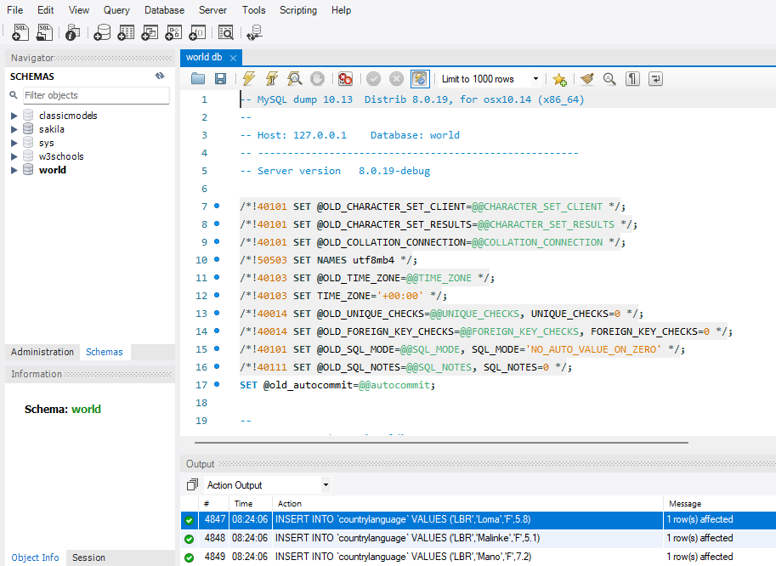

ONCE EXECUTED YOU WILL SEE THE BELOW ACTIONED OUTPUT

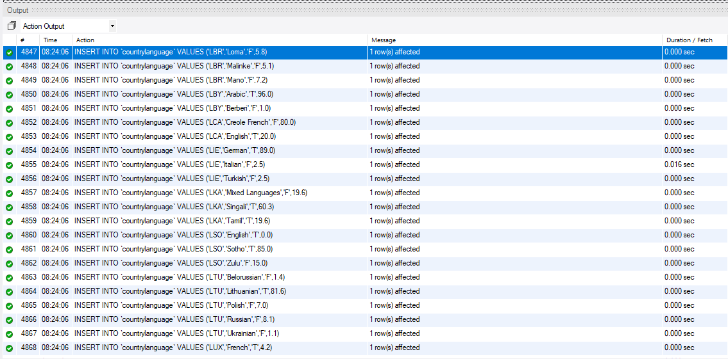

**NEW QUERY TAB**

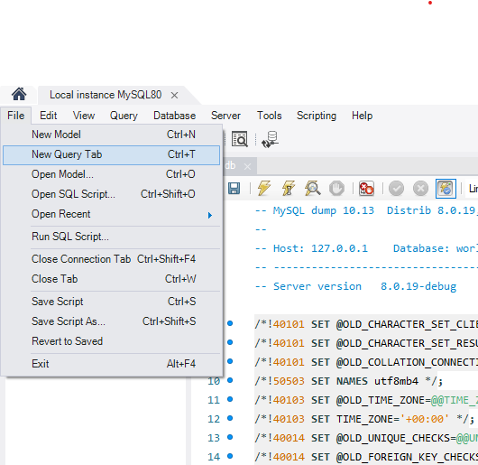

**SAVING TASK AND QUERIES**

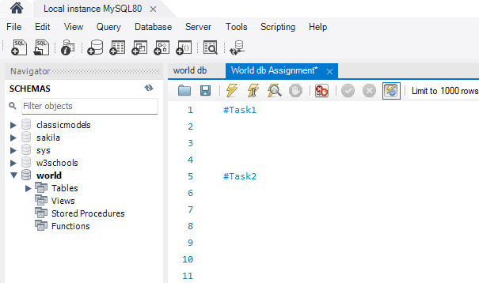

**USING COUNT, GET THE NUMBER OF CITIES IN THE USA**

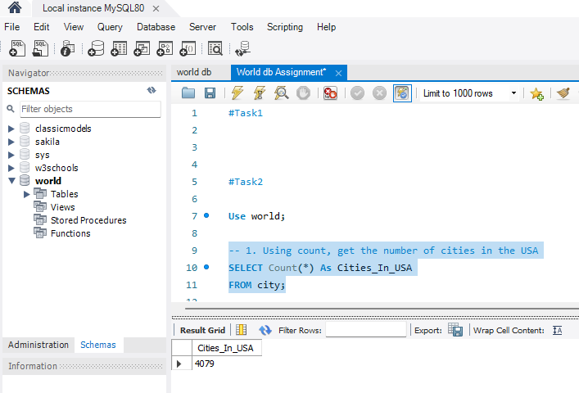

**FIND OUT WHAT THE POPULATION AND LIFE EXPECTANCY FOR PEOPLE IN ARGENTINA (ARG) IS**

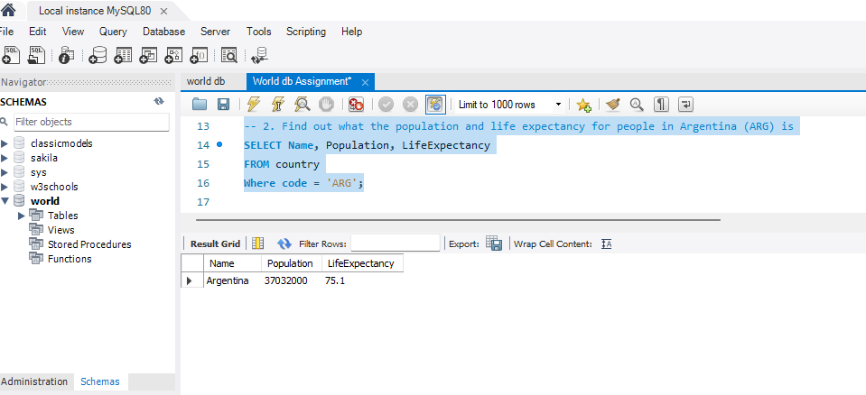

**USING ORDER BY, LIMIT, WHAT COUNTRY HAS THE HIGHEST LIFE EXPECTANCY?**

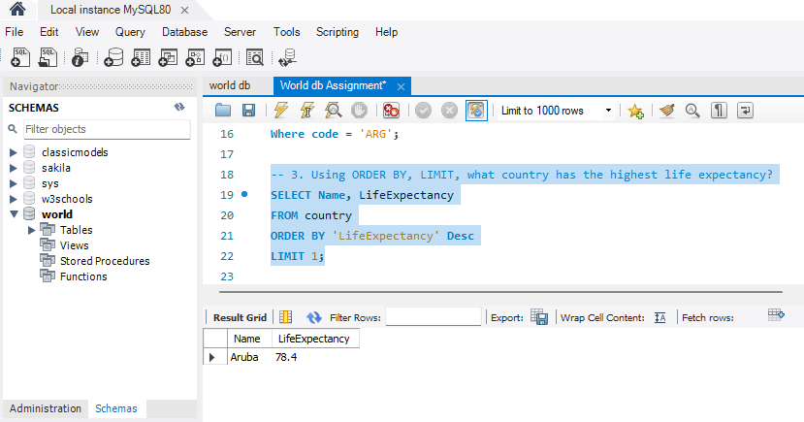

**SELECT 25 CITIES AROUND THE WORLD THAT START WITH THE LETTER 'F' IN A SINGLE SQL QUERY.**

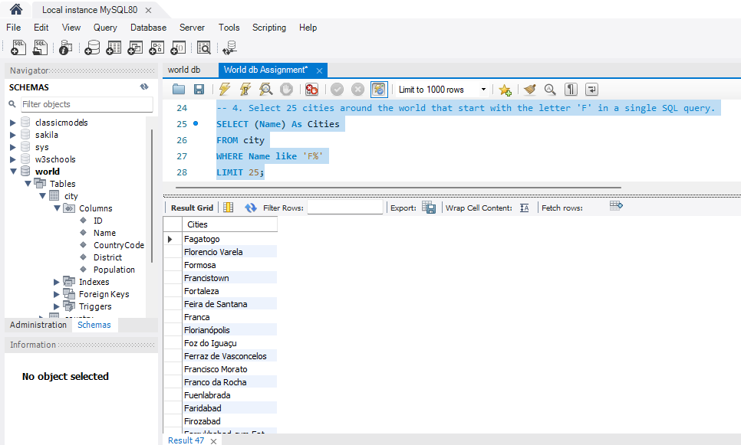

**TASK 13: CREATING AN EER DIAGRAM**

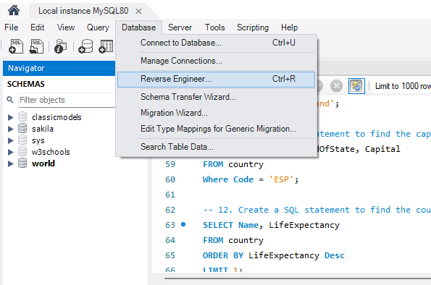

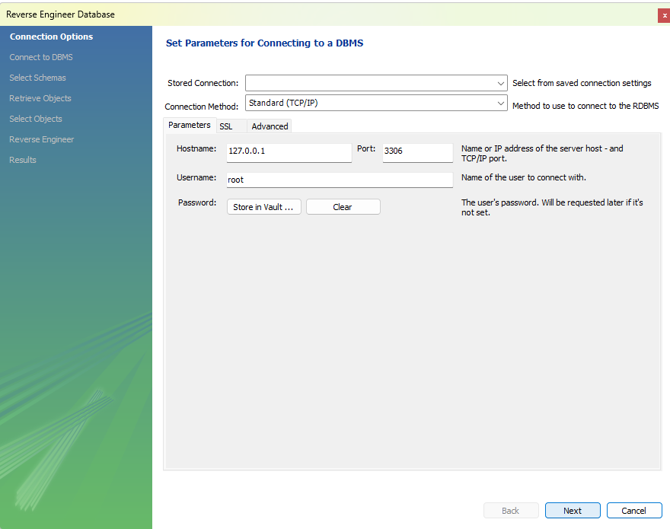

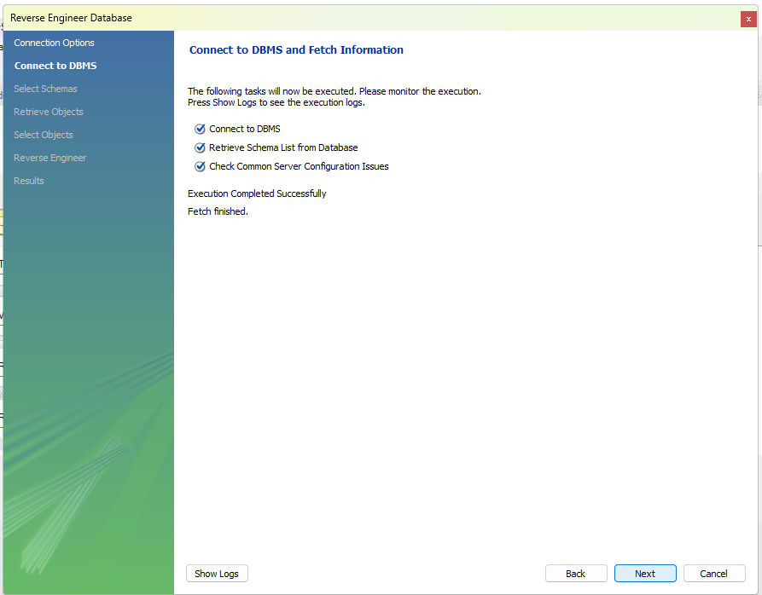

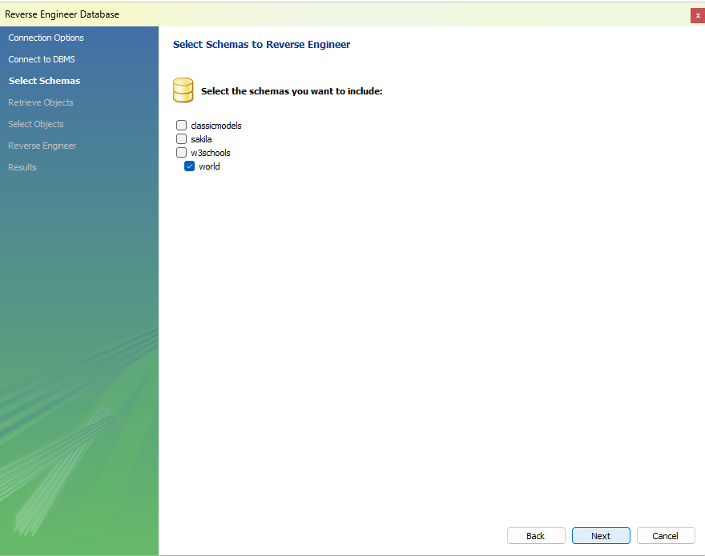

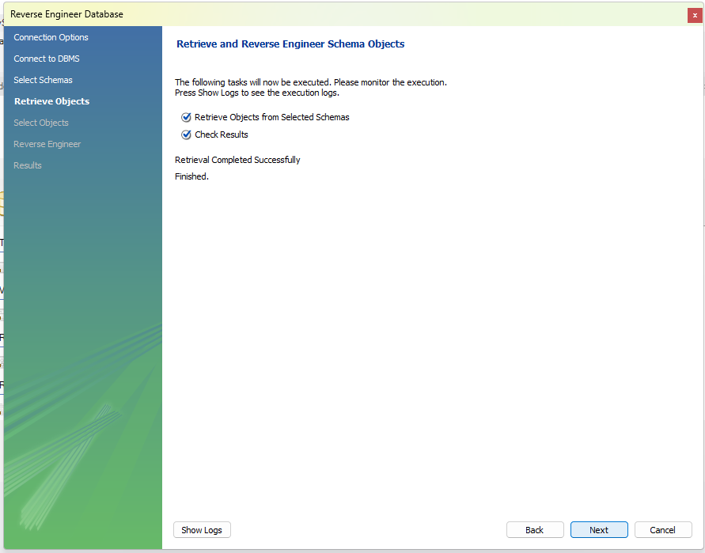

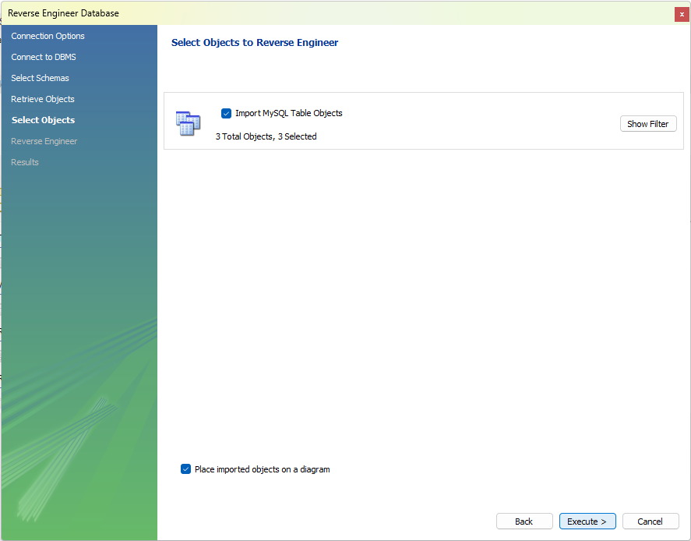

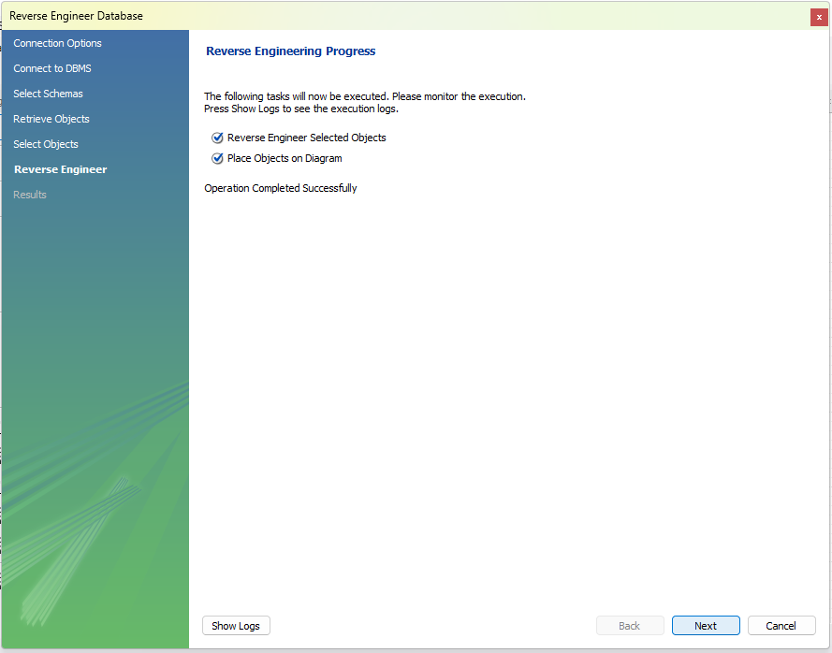

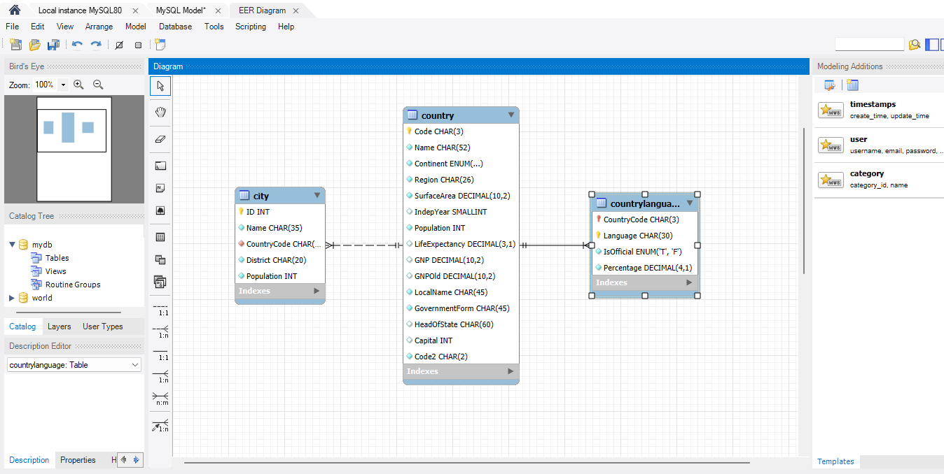

**IDENTIFY THE PRIMARY KEY IN COUNTRY TABLE**

The primary Key on the Country table is the Code

**IDENTIFY THE PRIMARY KEY IN CITY TABLE.**

The primary key on the City Table is the ID

**IDENTIFY THE PRIMARY KEY IN COUNTRYLANGUAGE TABLE**

The primary Key on the Countrylanguage is Language

**IDENTIFY THE FOREIGN KEY IN CITY TABLE**

The Foreign Key on the City Table is CountryCode

**IDENTIFY THE FOREIGN KEY IN COUNTRYLANGUAGE TABLE**

The Foreign Key is CountryCode